Khangai Herds 9- The Naadam
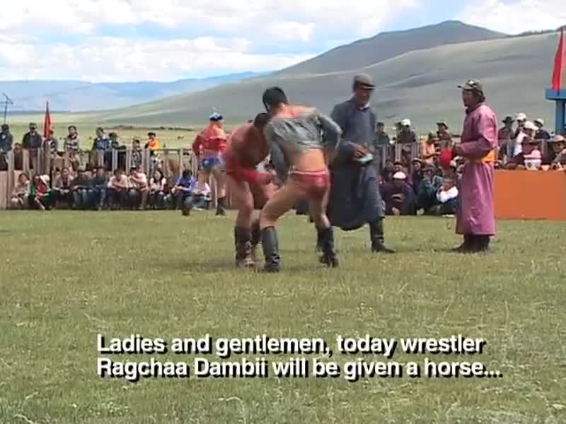

identifier
946bbc4f-042d-4c1b-918e-4e9ea0ef726e

creator
Fijn, Natasha

type
Moving Image

coverage
Mongolia

description
This ninth segment of Khangai Herds features an important event on any Mongolian herder's calendar: the Naadam. This is a festival celebrating the strength and prowess of herder and horse. Winning racehorses are blessed with fermented mare's milk and odes to their remarkable speed and endurance.

publisher

source
<https://vimeo.com/14324771>

rights
<https://creativecommons.org/licenses/by-nc-nd/3.0/>

subject
Khangai Herds
Living with Herds
Naadam
ceremony
domestication
ethnography
festival
horse
horse racing
jockey
observational film
pastoralism
racehorse
visual
wrestling

date
2010-08-21

language
Mongolian

format
video/mp4

contributor

original filename
Khangai Herds 9- The Naadam.mp4

remote embed url
https://player.vimeo.com/video/14324771

relation

extent
52.5MiB
617.905000

